DBMS lab -1

**Create Table, Alter, Insert, Update, Delete and Drop**

**Table Creation**

create table department(id int primary key, name varchar(50));

Output

Table Created.

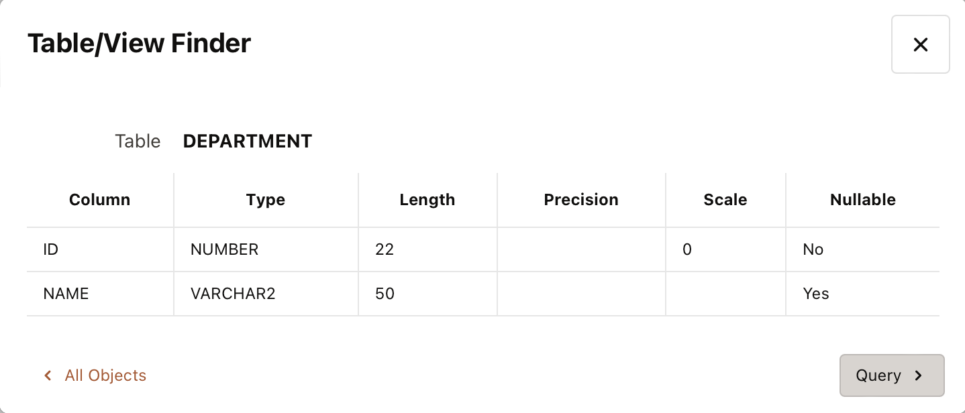

create table employee(id int primary key, name varchar(50), department_id int, foreign key (department_id) references department(id));

Output

Table Created.

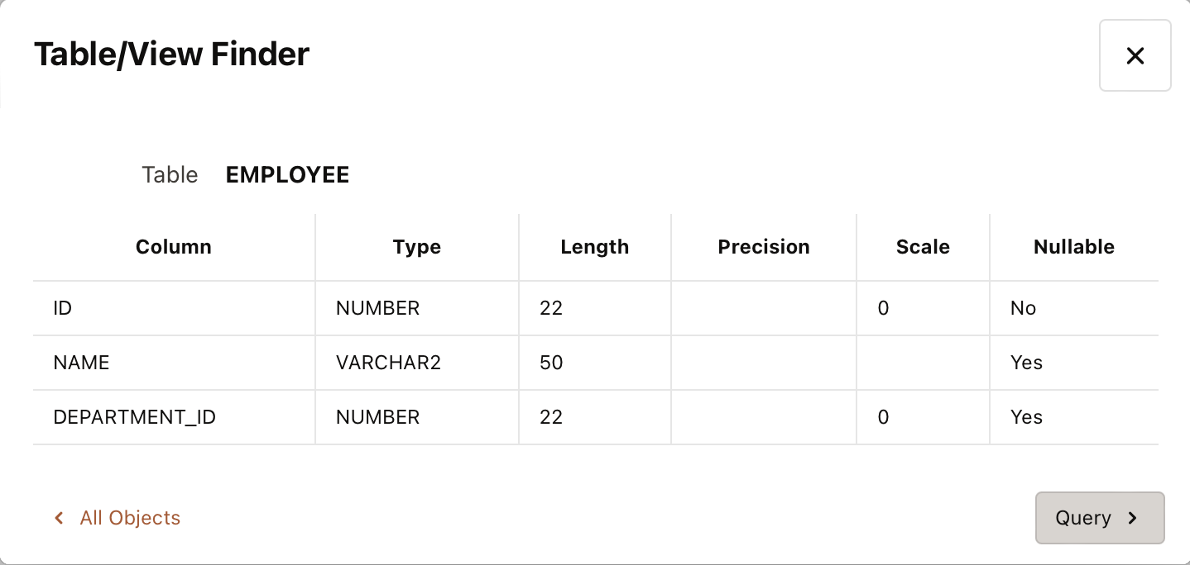

**Insert into Tables**

insert into department values(1,'IT');

insert into department values(2,'HR');

insert into department values(3,'Finance');

Output

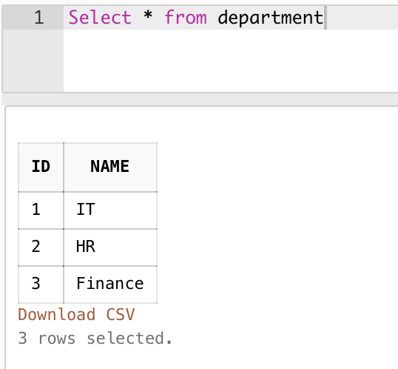

insert into employee values(1,'John',1);

insert into employee values(2,'Mary',2);

insert into employee values(3,'Peter',3);

insert into employee values(4,'Steve',1);

insert into employee values(5,'Bill',2);

insert into employee values(6,'Ram',3);

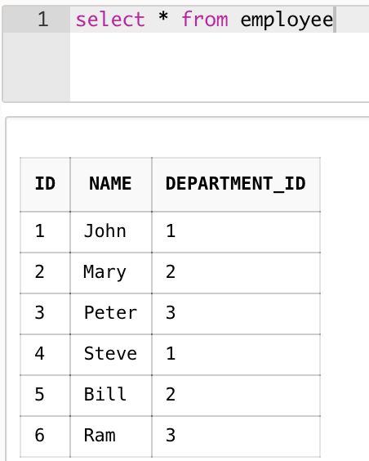

**Update the table**

update employee set department_id=2 where id=3;

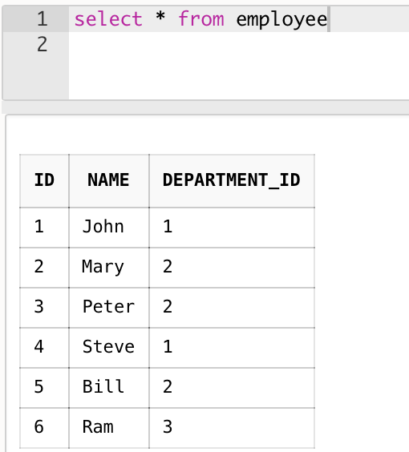

**Delete the table**

delete from employee where id=2;

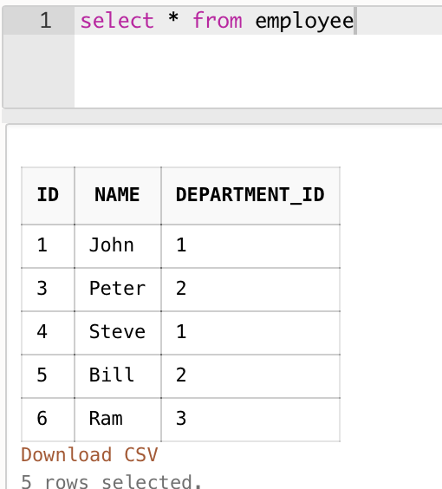

**Create a sample table and drop it**

create table dump(id int primary key, name varchar(50));

drop table dump;

Output

Table dropped.